**` 12.AWS-EC2-EBS_Volumes & Instance Store**

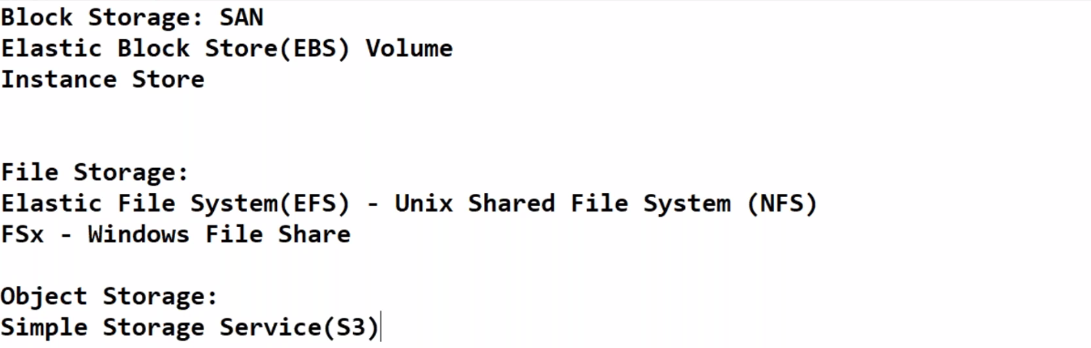

**EBS_Volumes**

We can assign 2 storages to the instances 1. server local storage 2. EBS-Volumes

Single EBS volume is attached to single ec2 instance only, we cannot attach single EBS to 2 instances

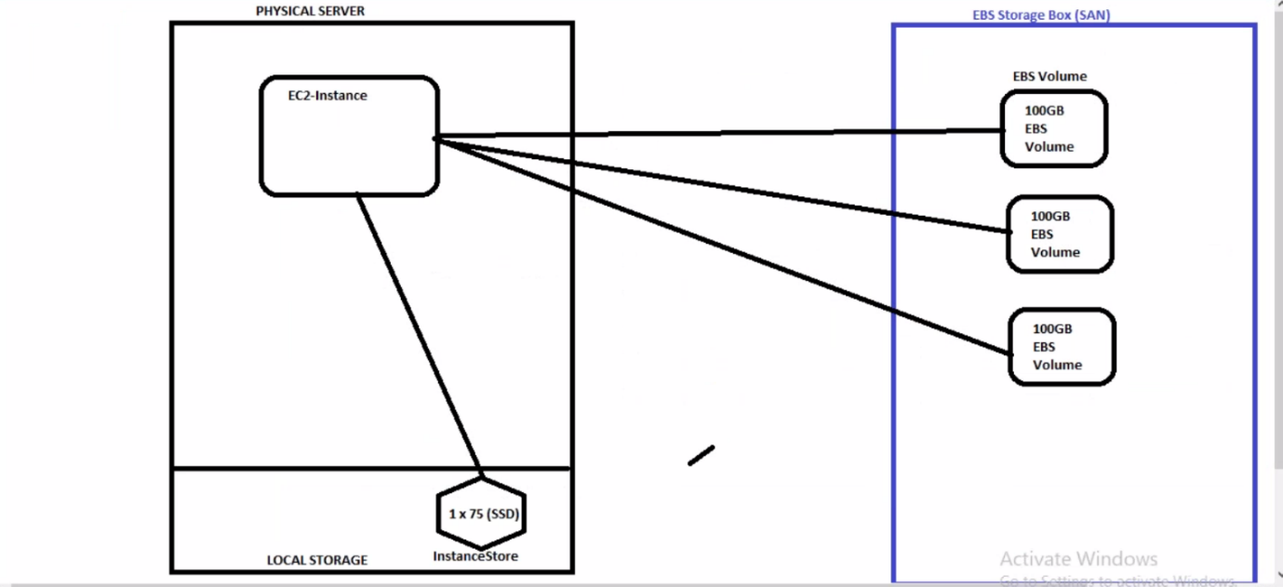

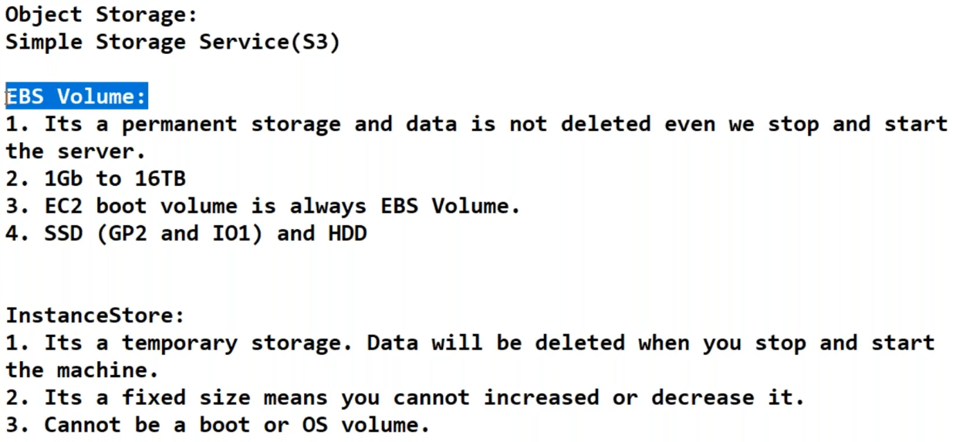

--- **QUES What is the difference between EBS and instance storage…?**

EBS is a centralized storage where instance storage is physical server local storage

--- **chkconfig nginx on** – this command means even when you reboot the server the nginx is still in active state.

**EBS attaching to instance and volume creating**

Create the volume in the same region as instance (instance created in 1a and create the EBS in 1a)

--- **lsblk** – list of volumes presents in the server.

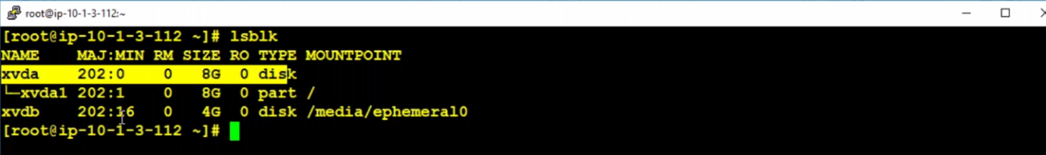

--- **How attach a volume to ec2 instances…?**

Go to the volumes and create a volume and then wait for the volume to available once it available then attach the volume to the machine.

--- **df -h** – this command will show the mounting points.

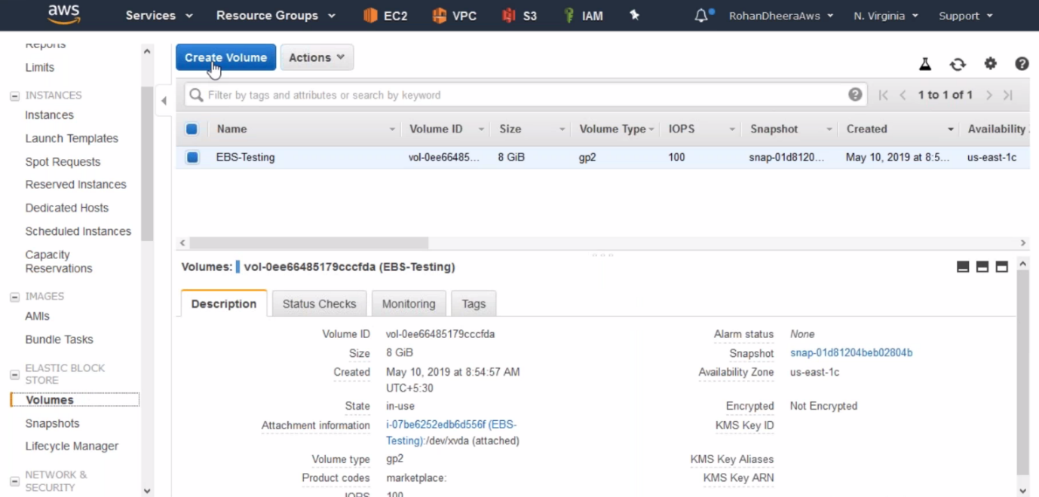

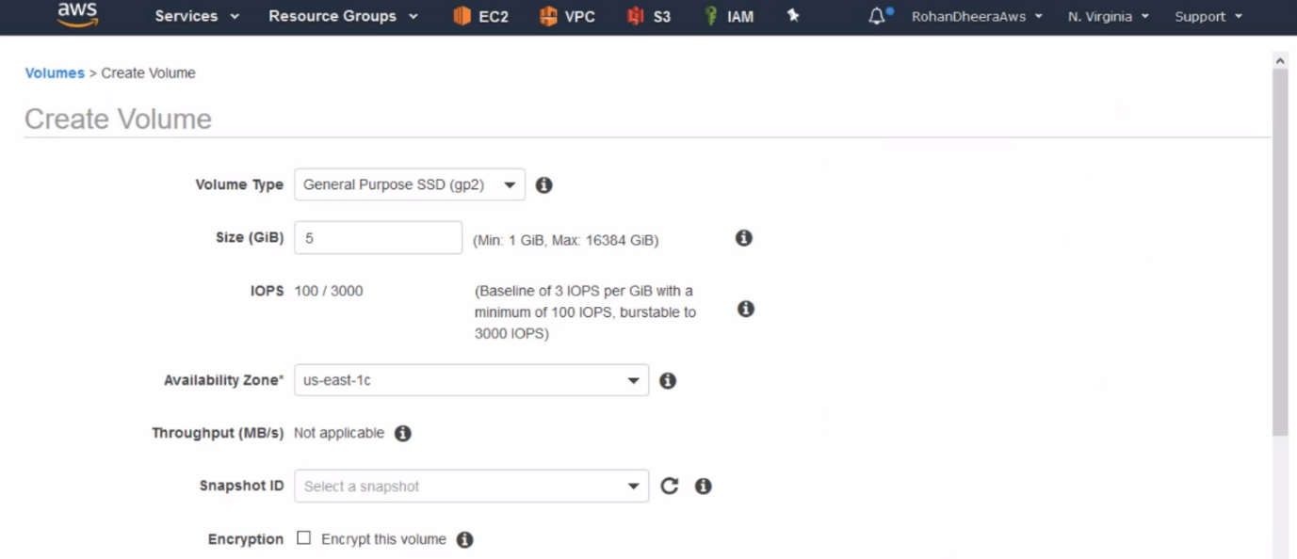

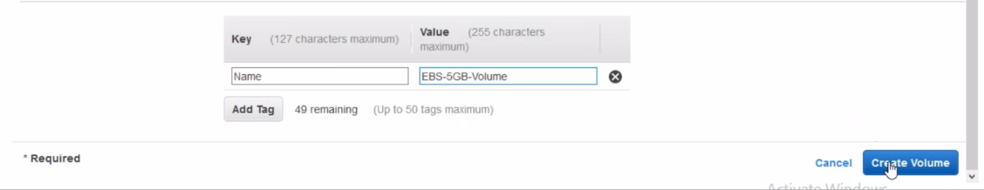

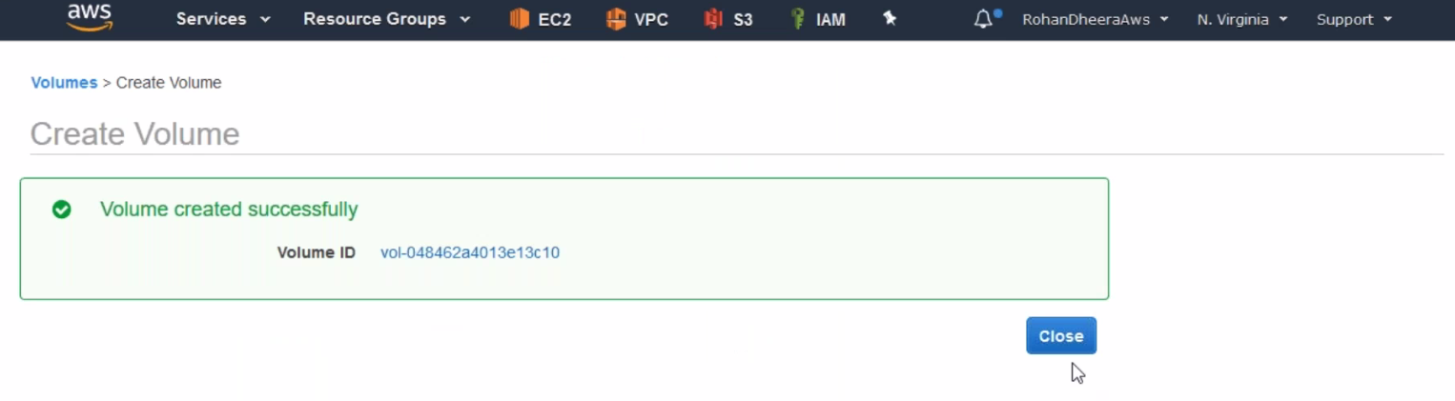

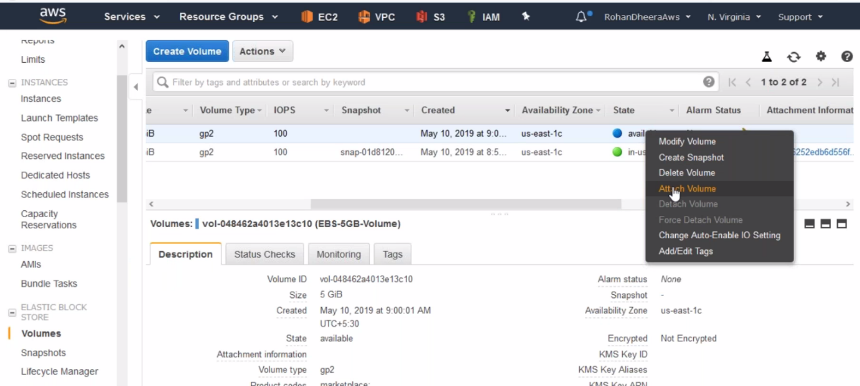

--- if the state is available then assign to instance.

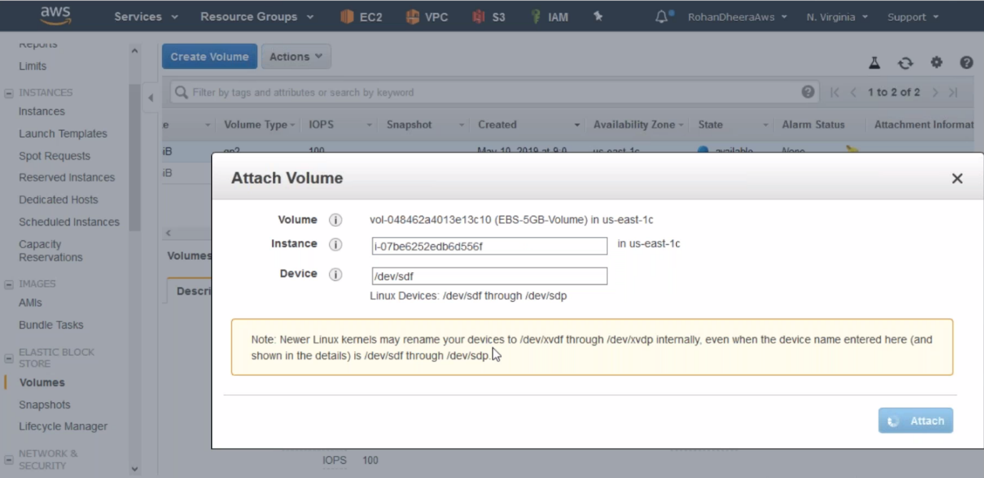

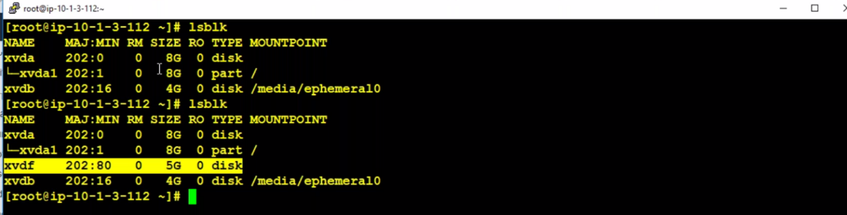

--- now it is showing 5GB storage

**format 🡪mkfs (make a file system) 🡪 mount**

the disk is assigned successfully and we have to do above 3 steps

**format**

--- **fdisk /dev/xvdf** – after dev give 5GB disk name.

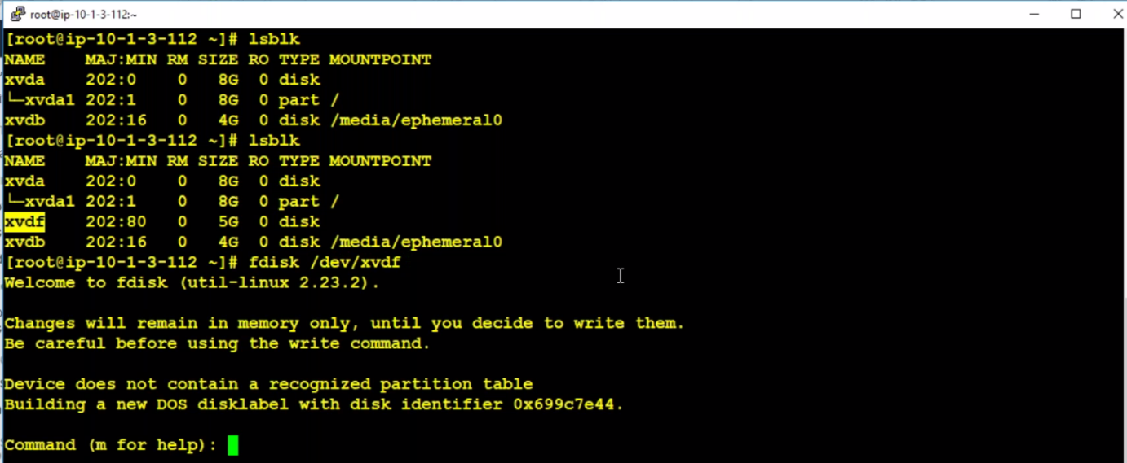

--- enter m for help

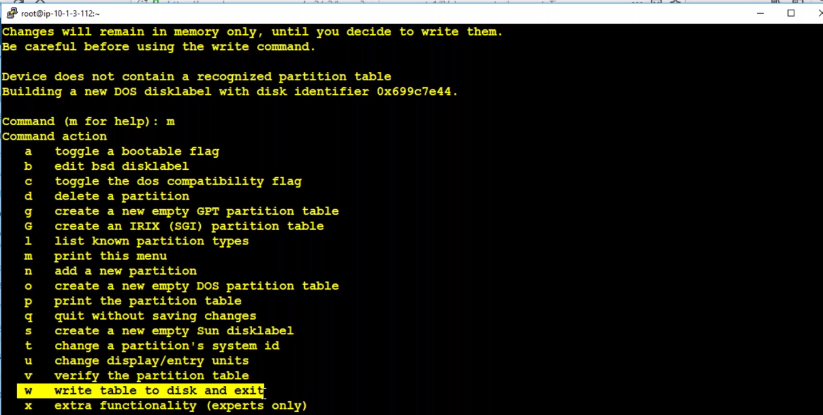

--- pnwp

--- p

--- n 🡪 4 times

--- w

--- fdisk /dev/xvdf

--- p

--- q

**mkfs (make a file system)**

--- **mkfs.ext4 /dev/xvdf1** – for creating file system.

--- **mkdir /ebsvolume** - creating a folder

**mount**

--- **mount /dev/xvdf1 /ebsvolume** – assigning volume to the ebsvolume.

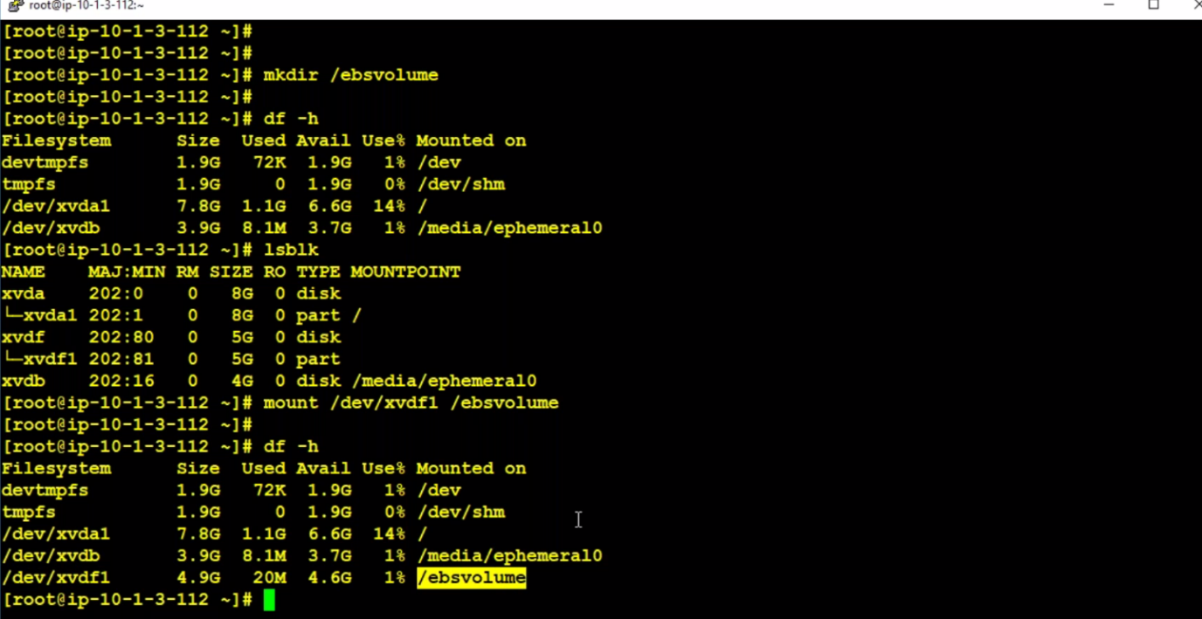

--- **cp testfile* myfolder1/** - coping all files copied to myfolder1.

--- **cp testfile* /media/ ephemeral0** – we are copying the file to another drive.

--- **ephemeral0** – means temporary

--- **nano /etc/fstab** – in this file we have to mention the mounted volume. If don’t mention in this file the data will be deleted in case of any server reboot or restart. Like this ( **/dev/xvdf1 /ebsvolume ext4 defaults 0 0**)

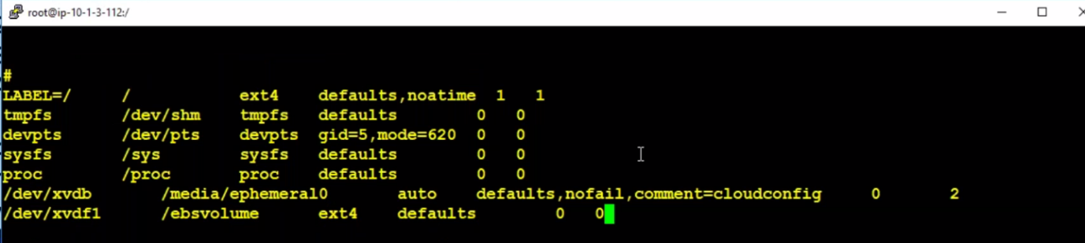

**EBS volume increasing**

--- **etc/fstab/options/** - search this command in google and you will know the commands.

--- **QUES how to modify the volume or increase the volume...?**

Click on the existing volume and modify the volume to wanted level. The server-side volume won’t increase automatically. We have to increase the partition of the disk manually. You cannot decrease the volume.

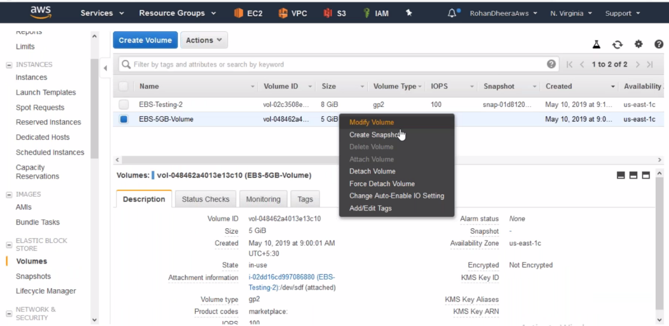

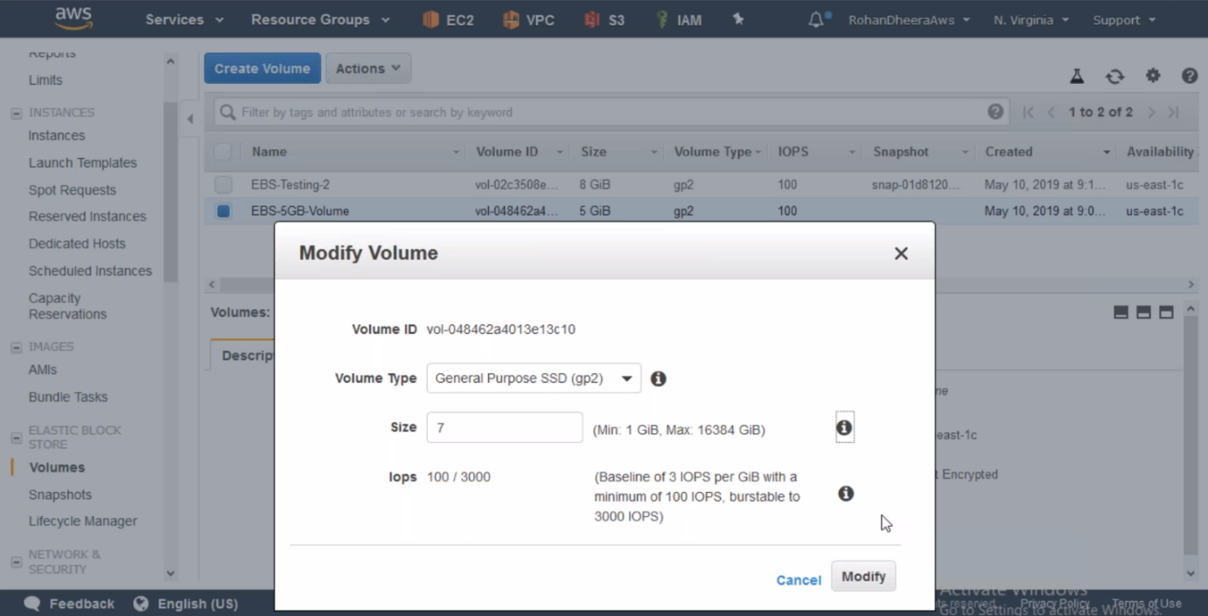

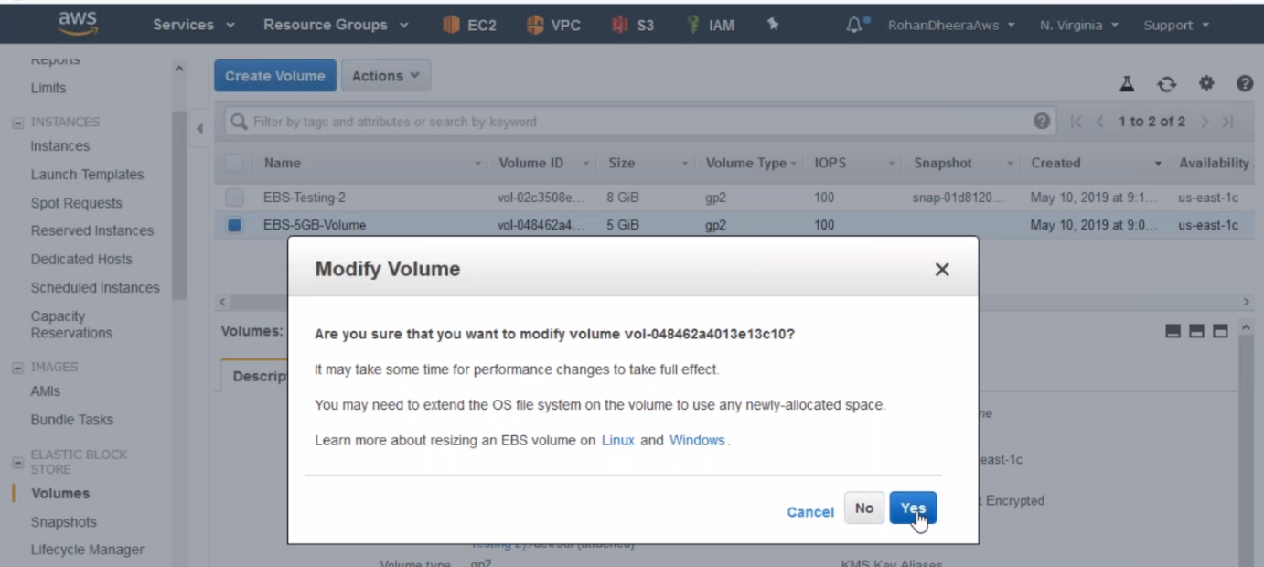

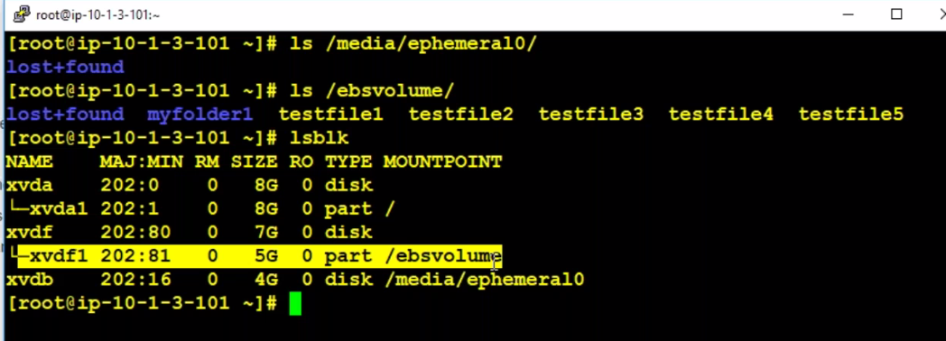

--- we need to increase the disk size here. Or increase partition size.

--- **growpart /dev/xvdf 1** – this command will increase the partition.

--- **resize2fs /dev/xvdf1** – now the disk size increased (extended.)